### CAST Analysis on Domestic Robot Accident

# System Description:

The system description will describe the detailed functionality the SLAMMIE robot and how it works.

The system includes the following components:

* SLAMMIE robot
* Controller
* Base Station
* Sensors
* Emergency backup (Front Desk, Doctor/Hospital)

# System Model Diagram:

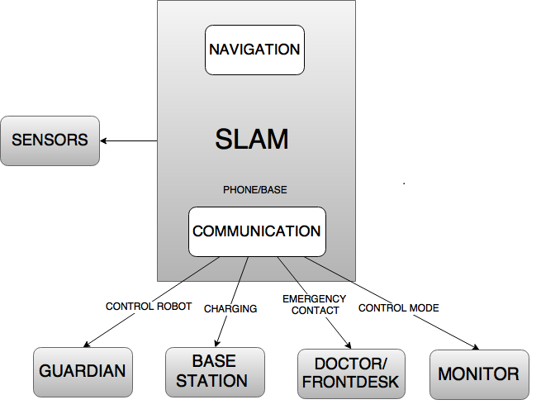

# Accidents:

* A1: Death of 98 year old, Millie Kiesewetter

# Hazards:

* H-1: SLAMMIE loses contact with base charging station
* H-2: Robot shutdown, before it could give information to the emergency services
* H-3: Floor was slippery due to flower vase
* H-4: Equipment Failure